***Project Name****:-* ***Pharmeasy.com***

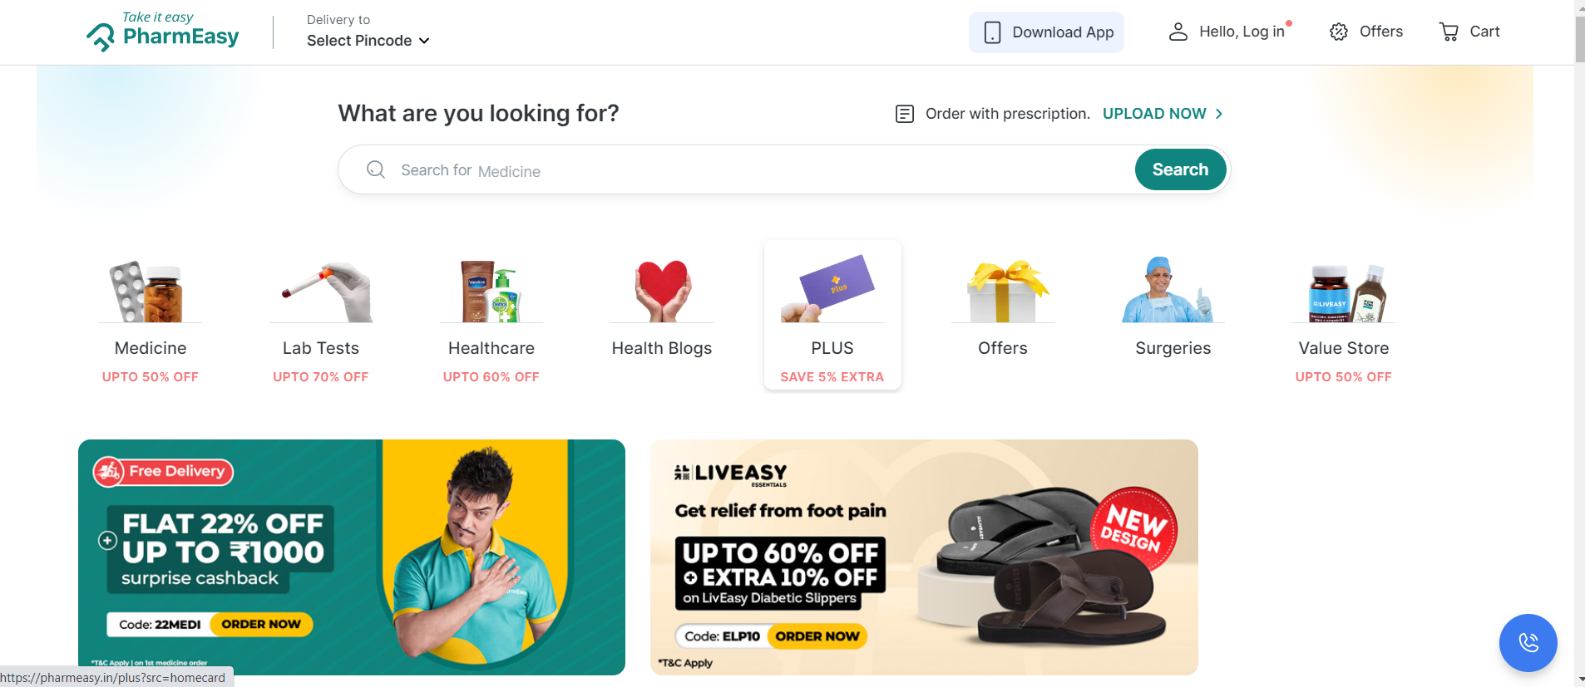

***ABOUT:***

* The company was started in 2015 by Dharmil Sheth and Dhaval Shah in Mumbai.
* PharmEasy is a consumer healthcare “super app” that provides consumers with on-demand home delivery.
* Home delivered access to a wide range of prescription.
* Provides service OTC pharmaceutical, other consumer healthcare products, comprehensive diagnostic test services, and teleconsultations

***Pages:***

1. **Login Page/SignUp Page**

* Just like a usual login page, asks user to enter login id and password.or SignUp.

1. **Home Page**

*2.1 Header*

* + - Navigation Bar
    - Logo
    - Icons - (Wishlist, Add to Cart)
    - User Profile

*2.2 Main*

* + - Search Bar
    - Sliders with Arrows - (Images)
    - Offer Section
    - Category Section
    - Lab Test Section
    - Trending New
    - Shop by Concern Section
    - Feature Brand Section
    - Deals of the Day Section
    - Health Articles Section
    - Customer Revies
    - more....................

*2.3 Footer*

* + - Contact Us , Helplines , Brief Description
    - About the Company , Social-Media Handle
    - Icons, Link to MobileApp

1. **Product Page**

* Detail of Product
* Price and Reviews
* Ratings
* more………..

1. **Add to Cart Page**

* Summary of Product

1. **Shipping Address**

* Form to fill Shipping Address

1. **Payment Page**

* Shipping Address
* Payment options available

1. **Tracking Page**

